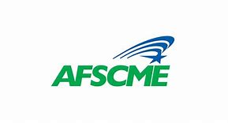

**Local 641**

**TO:** AFSCME Local 641 Members

**FROM:** Kevin Mello, President

**DATE:** September 4, 2024

**RE:** Open Enrollment -Sick Leave Bank Donation Form*

In order to participate in the Sick Leave Bank for this year, **this application must be submitted to Local 641 Recording Secretary, Gina Brites (PPS, PRAB Rm. 220), no later than October 5, 2024**.

* *If you are already a sick bank member, you do not need to fill out/submit this form! Donating to the Sick Leave Bank does not affect your Sick Leave Incentive.*

**As an AFSCME Local 641 member, in good standing, I wish to join and donate one (1) day to the Sick Leave Bank:**

NAME (Please print legibly):

SIGNATURE:

DEPARTMENT:

SCHOOL: