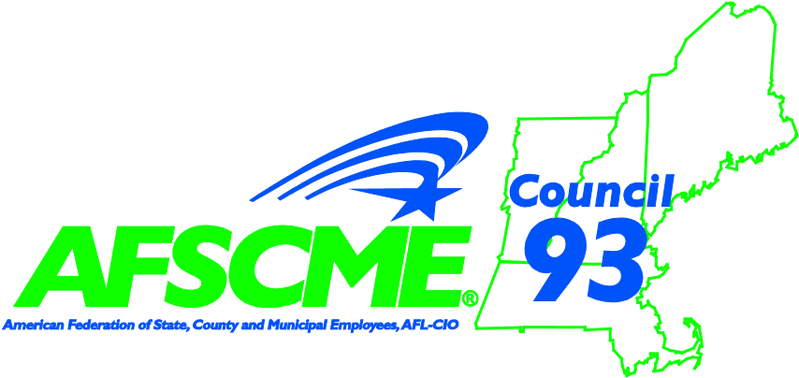
City of Boston &
AFSCME Council 93
Tuition Reimbursement

If you are a City employee and a member in good standing for the previous six (6) months of a participating City of Boston AFSCME local, you may be eligible for tuition reimbursement. As an AFSCME member, you may apply for up to $2,500 per fiscal year for courses you take to further your education or career growth.
Here’s how it works. You enroll in a course (or courses) at an accredited institution. When you complete the course, you furnish proof of payment and a passing grade to AFSCME’s Training & Career Ladder Committee. You can then be reimbursed up to $2,500 of the tuition you paid.

How To Apply
- Fill out the City of Boston Tuition Reimbursement Request Form (attached). Return it to William Chiasson, AFSCME Council 93, 116 Flanders Road, Westborough. MA, or fax the information to (617) 367-6021. Applications must be received by October 15th for the Summer and Fall semesters and May 15th for the Winter and Spring semesters.
- When you have completed the course, send proof of payment and proof of a passing grade to the address above.
Your request will then be processed and a check will be mailed to you. When the funds for the fiscal year are exhausted, no more payments will be made. Requests must be for courses taken in the current fiscal year, between July 1st and June 30th.
*If you have any questions regarding the AFSCME tuition reimbursement or any other AFSCME
Training & Career Ladder program, please contact your Local Union’s President or Metro Coordinator William Chiasson (617) 367.6042 or by e-mail at wchiasson@afscme93.org

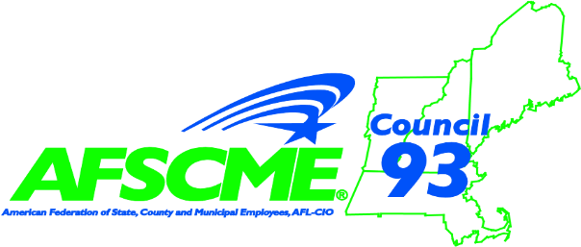
AFSCME COUNCIL 93 TRAINING

& CAREER LADDER
C/O William Chiasson
116 Flanders Road Westborough, MA 01581
PHONE: 617-367-6042 FAX: 617-367-6021

AFSCME TUITION REIMBURSEMENT REQUEST
City of Boston employees that are members of AFSCME Citywide may apply for up to $2,500 in tuition reimbursement for courses that they take to further their education or career growth. The tuition reimbursement will be issued when they complete the course and furnish proof of payment and a passing grade to the City’s Training and Development Unit.
Name:_____________________________________________Date:_________________
Dept/Div:__________________________________ Job Title: _____________________
Phone:______________________ Social Sec # ____________________________
Home Address:___________________________________________________________
E-Mail Address: __________________________________________________________
Your Collective Bargaining Unit (Local):_______________________

Institution/College:________________________________________________________
Course Title:_________________________________Date of First Class:_____________
Tuition Cost (do not include fees)________________Date of last Class:______________
Course Title:_________________________________Date of First Class:_____________ Tuition Cost (do not include fees)________________Date of last Class:______________
Step 1: Complete this form and send to AFSCME Training & Career Ladder Committee C/O William Chiasson at 116 Flanders Rd, Westborough, MA 01581.*Applications must be received by October 15th for the Fall semester and May 15th for the Winter and Spring semesters.
Step 2: As soon as you have the receipt of payment for the course and proof of a passing grade, send those documents to the fore mentioned address. We will process your request for reimbursement at that time. Payment shall be made for courses that are taken from July 1st through June 30th of each fiscal year.
*Please note that incomplete applications or applications that are not submitted by the above mentioned due dates, may be denied.
____________________________________ ______________________________

EMPLOYEE SIGNATURE LOCAL PRESIDENT SIGNATURE

